* Use SELECT, WHERE, ORDER BY, GROUP BY

SELECT * FROM Customers;

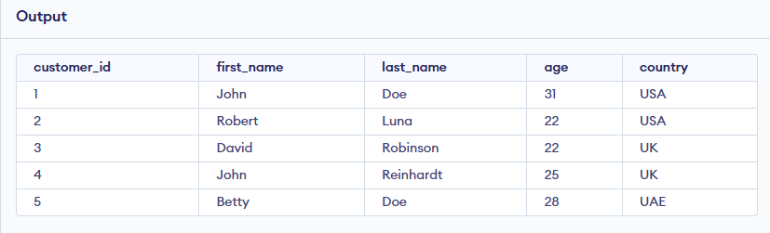

* SELECT first_name ,age FROM Customers where country="USA" ;

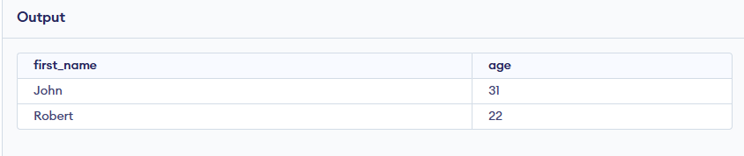

* SELECT first_name, age FROM Customers order by age ASC ;

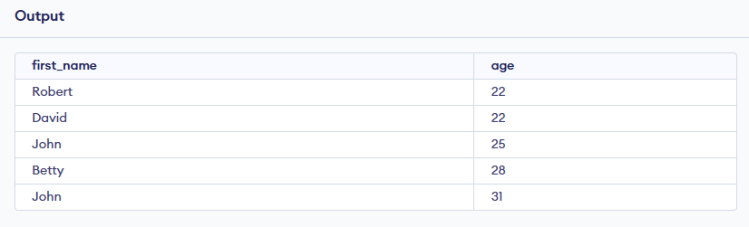

* SELECT COUNT (Customer_id), Country, first_name

FROM Customers GROUP BY Country;

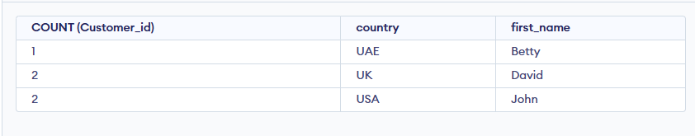

* Use JOINS (INNER, LEFT, RIGHT)

SELECT first_name, item, amount, country FROM Customers

INNER JOIN Orders ON Customers.customer_id = Orders.customer_id;

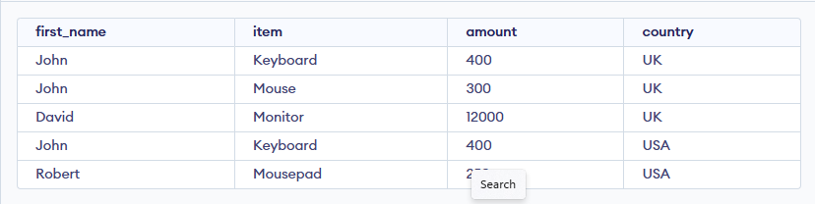

* SELECT Customers.customer_id, Orders.item, Orders.amount

FROM Customers LEFT JOIN Order ON Customers.customer_id = Orders.customer_id;

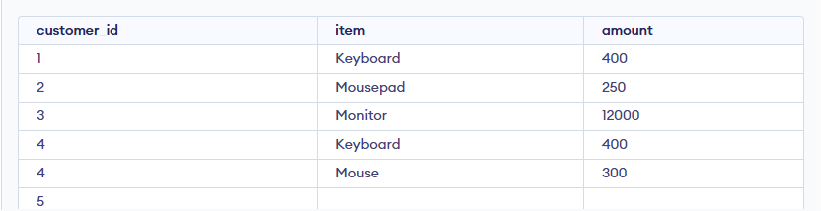

* Use aggregate functions (SUM, AVG)

SELECT Sum(amount) FROM Orders;

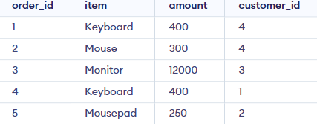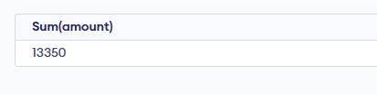

* SELECT AVG(amount) FROM Orders;

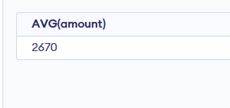

* Write subqueries

SELECT * FROM Orders

WHERE amount = (SELECT Max(amount) from Orders);



* Optimize queries with indexes

SELECT first_name, last_name FROM Customers

WHERE customer_id IN (SELECT customer_id from Orders WHERE item="Keyboard");

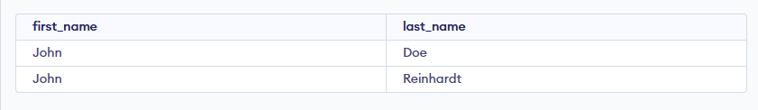

* Create views for analysis

CREATE view CUST_VIEW as SELECT first_name,last_name

FROM Customers WHERE customer_id=2;

SELECT * FROM CUST_VW;

